**Name: Session:**

**Programming II**

**Getting Started with Visual Studio**

**Lab Exercise 2.14.2023**

**Hello World in Visual C#**

1. Start Visual Studio

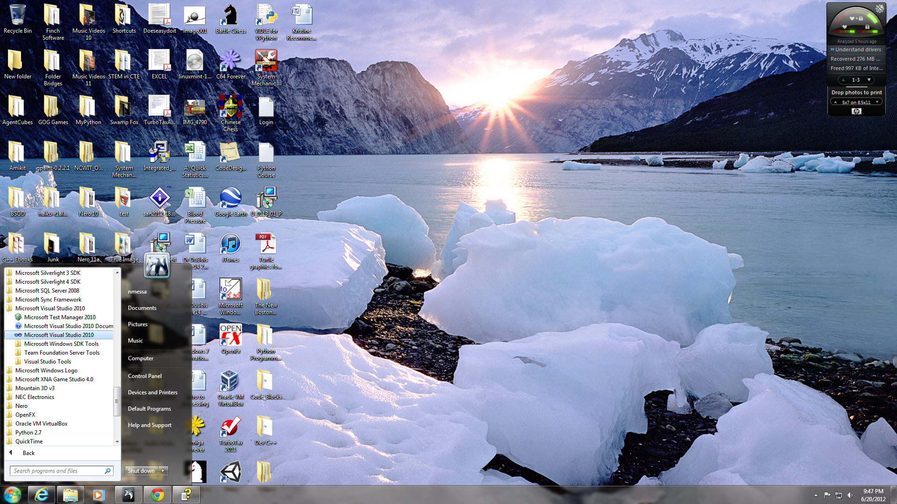

1. Once Visual Studio is running, select File|New|Project

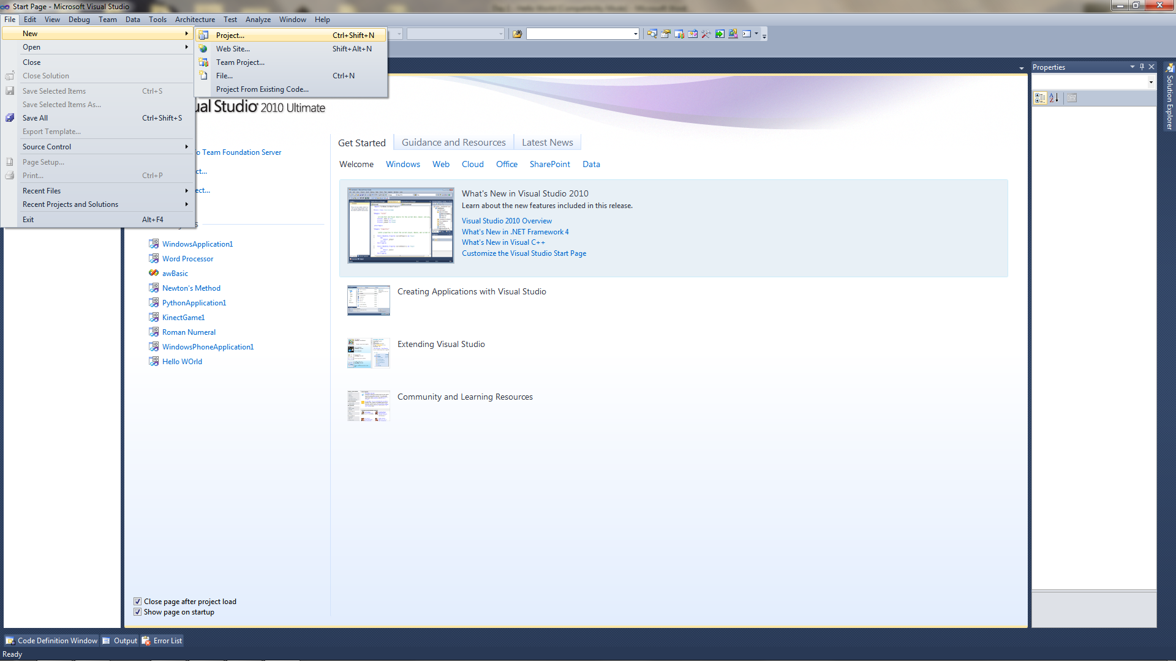

1. Select Visual C# Projects from Project Types and Windows Application from Templates. Type in the name of the project as HelloWorld. Click OK and your project will be created.

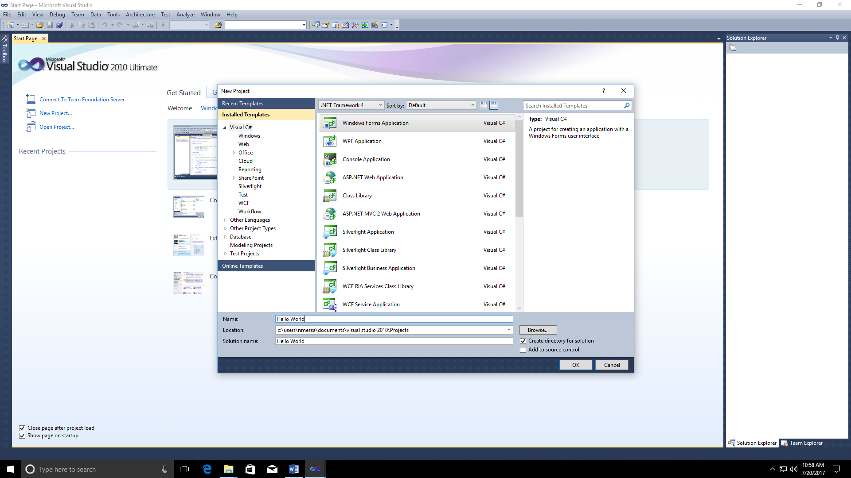

1. You should now have a project that looks like this:

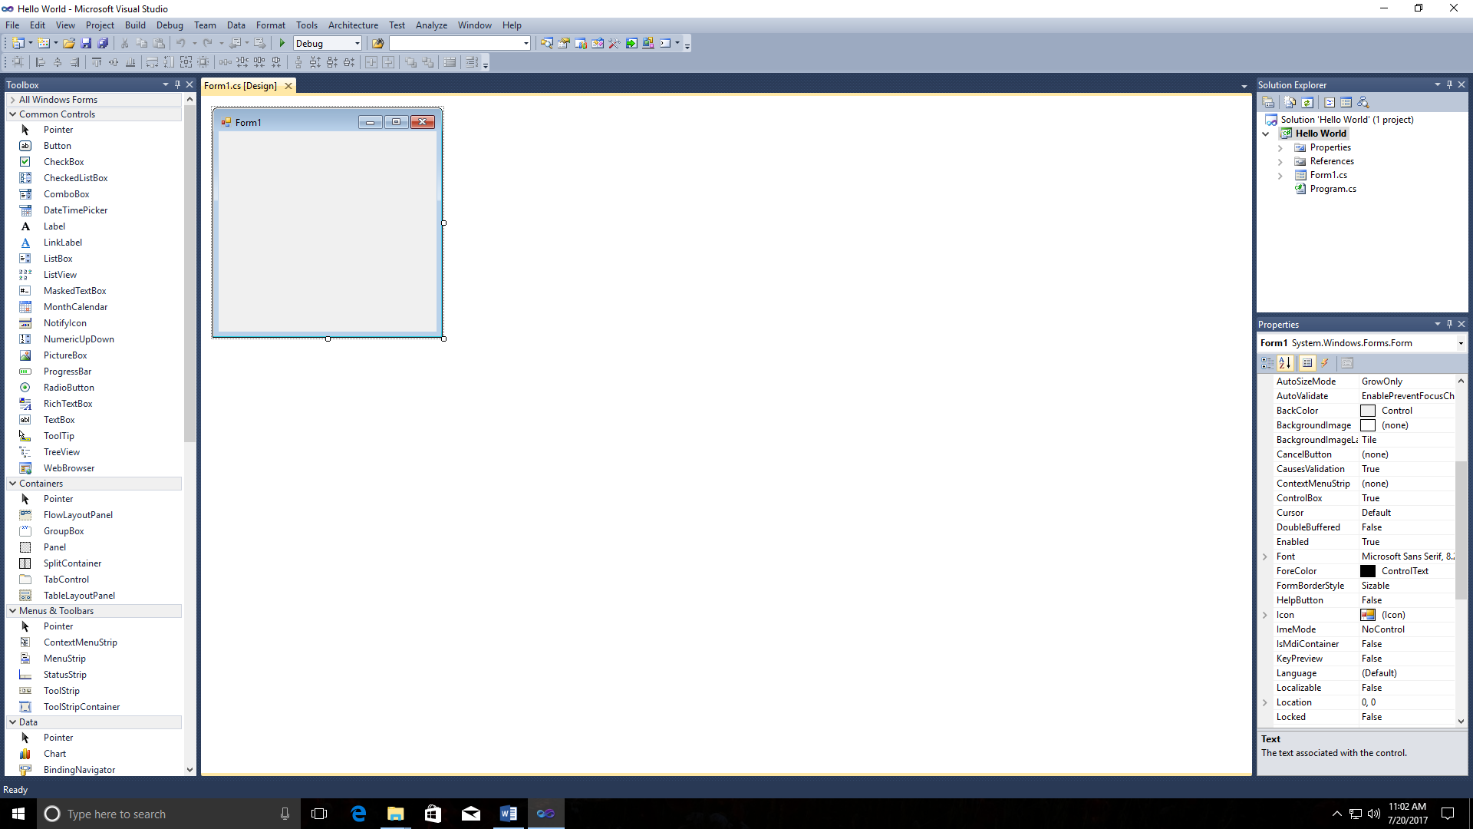

1. Notice the following:
   1. Form1 – a window that you can place things from the toolbox on
   2. Toolbox – things you can put on the form
   3. Solution Explorer – things in your project
   4. Property Inspector – information about the object you have selected
2. On out form, we are going to place two objects from our toolbox, a Label and a Button. When we place these objects on our form, Visual Basic gives them a name of Label1 and Button1 respectively. At this point we will not worry about renaming them but we will at some future point.

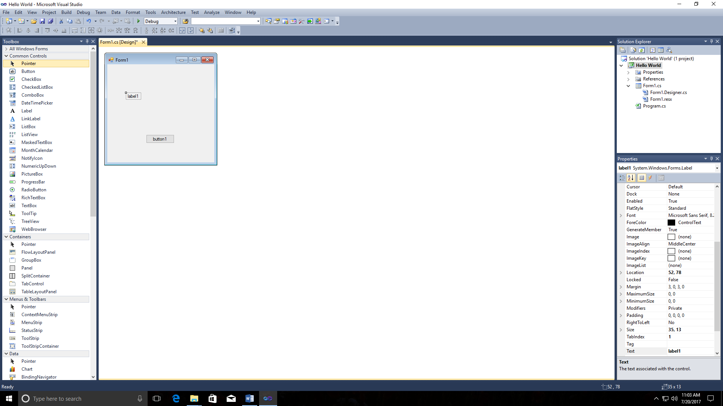

1. At this point we are going to change the Text property of button1 from “button1” to “Greeting” in the Property Inspector.

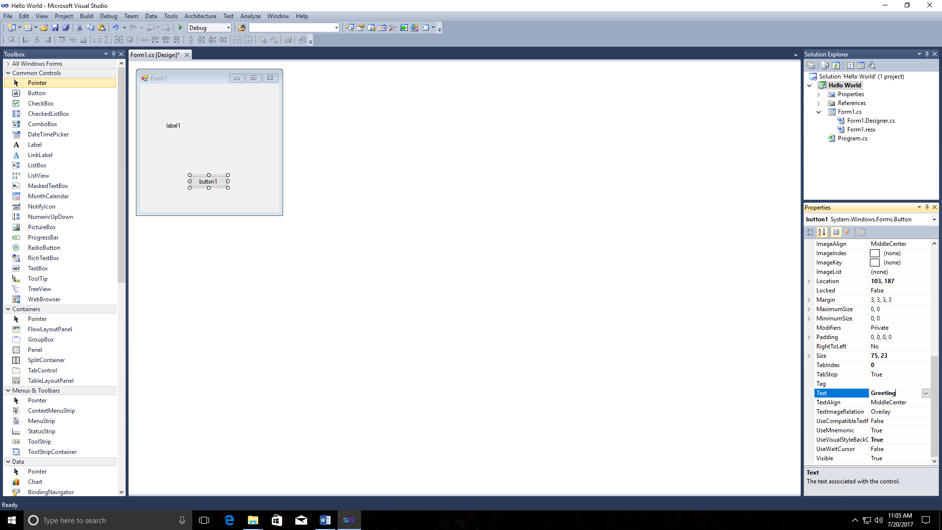

1. Now change the Text Property of the Label1 from “Label1” to Nothing (i.e. leave it blank). Your Form1 should now look like this.

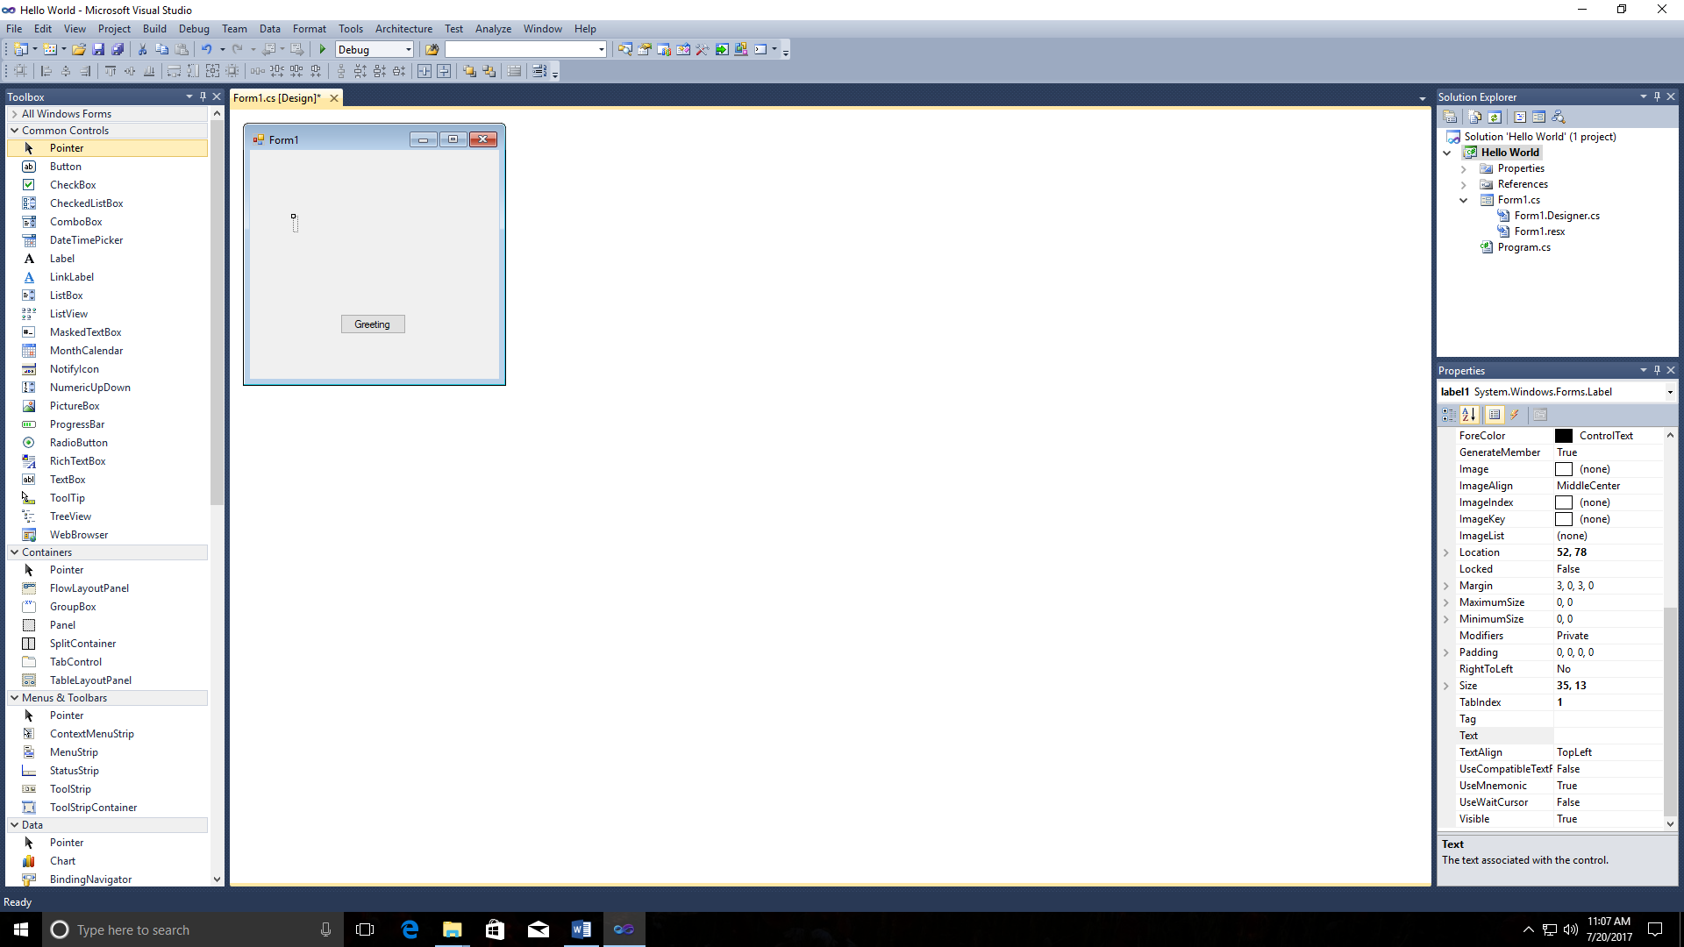

1. Now we are going to create an event so that when we click on the Greeting button, “Hello World!!!” will be placed in Label1.
2. Double-click on the Greeting button and a Click event will be created. Place the following line of code button1_Click event handler as such.

private void button1_Click(object sender, EventArgs e)

{

label1.Text = "Hello World";

}

1. Now click the Start button and your program should execute.

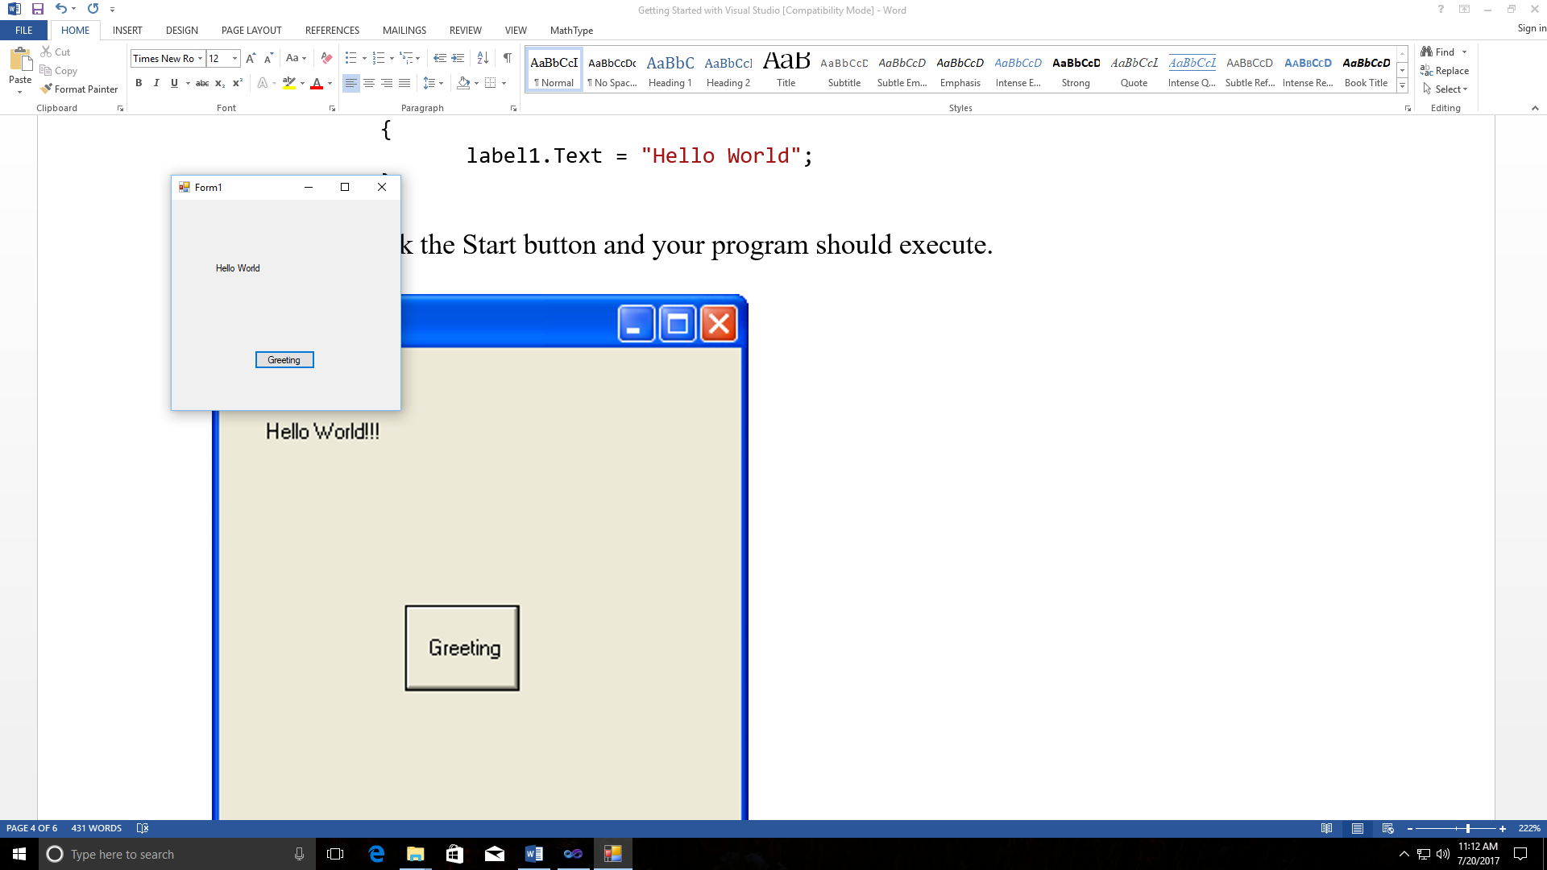

**Form Fun**

1. In this project, you will create a form with 6 buttons as shown:

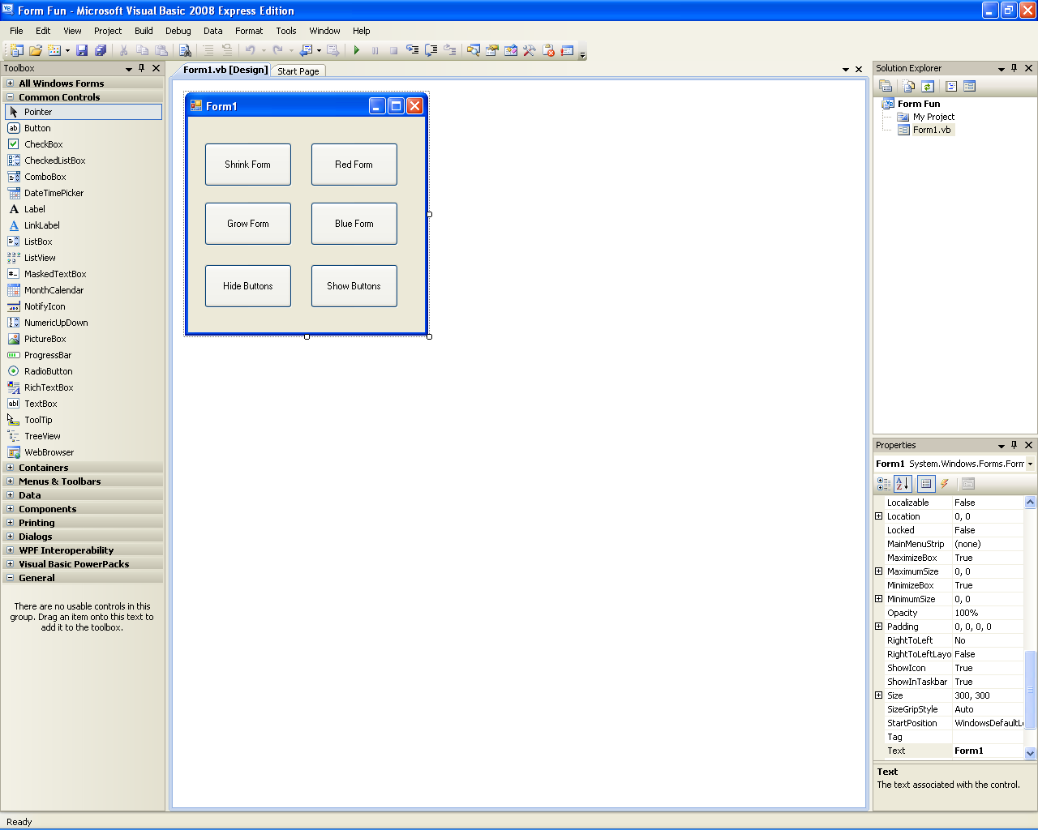

1. Assign the following properties to the buttons:

|  |  |  |
| --- | --- | --- |
| **Button** | **Text Property** | **Name Property** |
| button1 | Shrink Form | btnShrink |
| button2 | Grow Form | btnGrow |
| button3 | Hide Buttons | btnHide |
| button4 | Red Form | btnRed |
| button5 | Blue Form | btnBlue |
| button6 | Show Buttons | btnShow |

1. Make the Visible property of btnShow *false*.
2. Add the following Click Event code to the following buttons.

**btnShrink_Click**

this.Height = this.Height – 10;

this.Width = this.Width – 10;

**btnGrow_Click**

this.Height = this.Height + 10;

this.Width = this.Width + 10;

**btnHide_Click**

btnGrow.Visible = false;

btnShrink.Visible = false;

btnHide.Visible = false;

btnRed.Visible = false;

btnBlue.Visible = false;

btnShow.Visible = true;

**btnRed_Click**

this.BackColor = Color.Red;

**btnBlue_Click**

this.BackColor = Color.Blue;

**btnShow_Click**

btnGrow.Visible = true;

btnShrink.Visible = true;

btnHide.Visible = true;

btnRed.Visible = true;

btnBlue.Visible = true;

btnShow.Visible = false;

1. Now run your program and see what happens.

**Practice Problems**

1. Create an application that displays your name and address when a button is clicked as shown below. The form should have 3 labels names lblName, lblStreet, lblCityStateZip and have a Font property of Times New Roman, bold, 12 point with the labels TextAlign property set to MiddleCenter.

1. Create a Math Tutor application. The application should display a simple math problem in a Label control. The form should have a button that displays the answer in the same Label. The form should have a second button that closes the application.

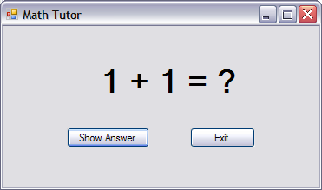

1. The following table lists 6 states and their official abbreviation.

|  |  |
| --- | --- |
| **State** | **Abbreviation** |
| Virginia | VA |
| North Carolina | NC |
| South Carolina | SC |
| Georgia | GA |
| Alabama | AL |
| Florida | FL |

Create an application that allows the user to select a state, and then displays the state’s official abbreviation. Hint: the form should have 6 buttons and 1 label.

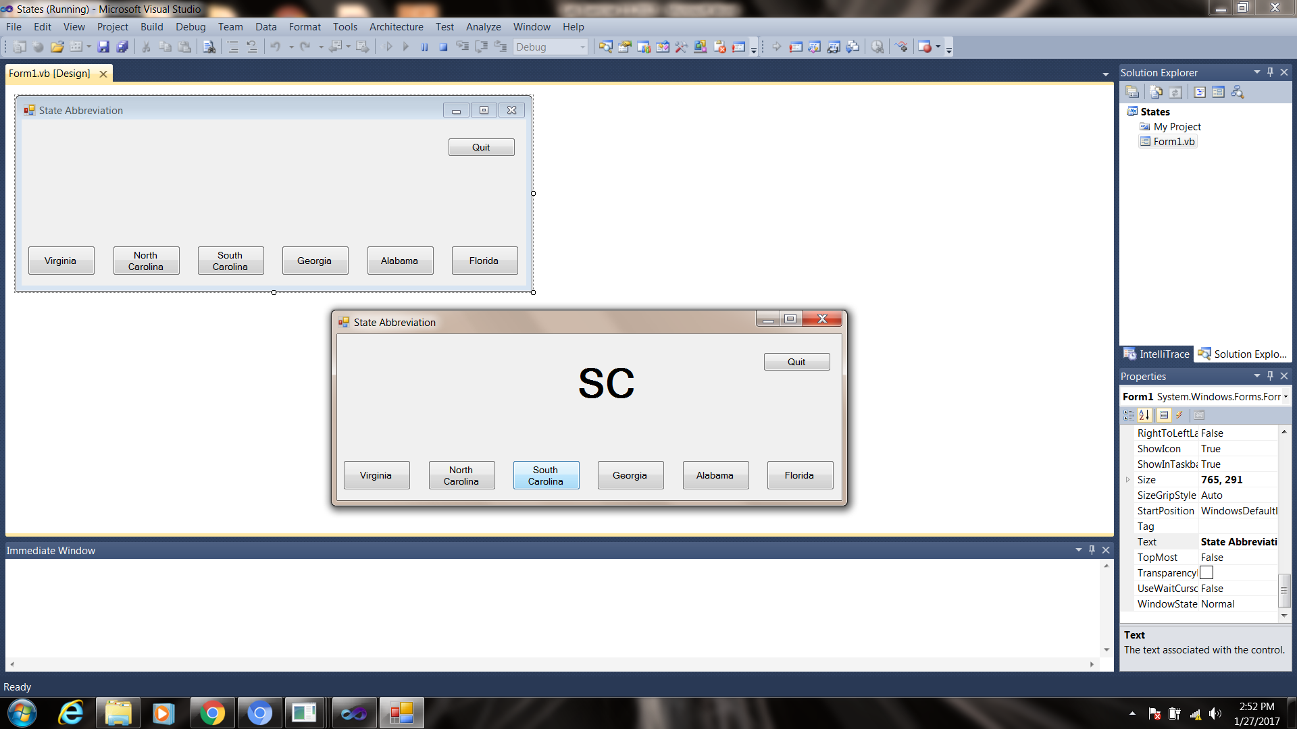

1. A joke typically has two parts: a setup and a punch line. For example, this might be a setup for a joke:

How many programmers does it take to change a lightbulb?

and the punch line:

None. That’s a hardware problem.

Think of your favorite joke that has a Setup button and a Punch Line button that displays in a label.

